**PIZZA SALES REPORT USING SQL QUERIES**

A. KPI’(s)

1. Total Revenue

SELECT SUM(total_price) AS [Total Revenue]

FROM pizza_sales;

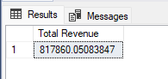

2. Average Order Value

SELECT SUM(total_price)/COUNT(DISTINCT order_id) AS [Average Order Value]

FROM pizza_sales;

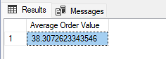

3. Total Pizza Sold

SELECT SUM(quantity) AS [Total Pizza Sold]

FROM pizza_sales;

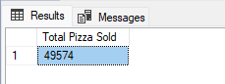

4. Total Orders

SELECT COUNT(DISTINCT order_id) AS [Total Orders]

FROM pizza_sales;

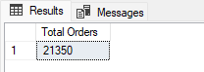

5. Average Pizzas per Order

SELECT CAST(CAST(SUM(quantity) AS decimal(10,2))

/CAST(COUNT(DISTINCT order_id) AS decimal(10,2)) AS decimal(10,2))

AS [Average Pizzas per Order]

FROM pizza_sales;

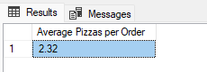

B. CHART’(s)

1. Daily Trend for Total Orders

SELECT DATENAME(DW,order_date) AS [Order Day], COUNT(DISTINCT order_id) AS [Total Order]

FROM pizza_sales

GROUP BY DATENAME(DW,order_date);

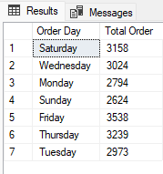

2. Monthly Trend for Total Orders

SELECT DATENAME(M,order_date) AS [Order Month], COUNT(DISTINCT order_id) AS [Total Order]

FROM pizza_sales

GROUP BY DATENAME(M,order_date)

ORDER BY [Total Order] DESC;

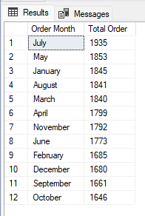

3. Percentage of Sales by Pizza Category

SELECT pizza_category , CAST(SUM(total_price) AS decimal(10,2)) AS [Total Revenue],CAST(SUM(total_price)*100 / (SELECT SUM(total_price) FROM pizza_sales) AS decimal(10,2)) AS [% of Total Sales]

FROM pizza_sales

GROUP BY pizza_category;

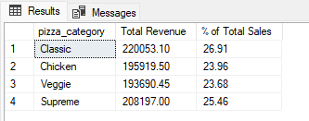

4. Percentage of Sales by Pizza Size

SELECT pizza_size , CAST(SUM(total_price) AS decimal(10,2)) AS [Total Revenue],CAST(SUM(total_price)*100 / (SELECT SUM(total_price) FROM pizza_sales) AS decimal(10,2)) AS [% of Total Sales]

FROM pizza_sales

GROUP BY pizza_size

ORDER BY 3 DESC;

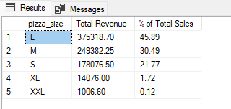

5. Total pizzas sold by pizzas category

SELECT pizza_category , sum(quantity) AS [Total Pizzas]

FROM pizza_sales

GROUP BY pizza_category

ORDER BY 2 DESC;

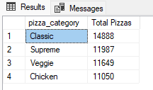

6. Top 5 Best seller pizzas by revenue

SELECT TOP 5 pizza_name , SUM(total_price) AS [Total Revenue]

FROM pizza_sales

GROUP BY pizza_name

ORDER BY 2 DESC;

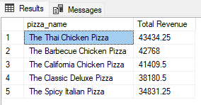

7. Bottom 5 Best seller pizzas by revenue

SELECT TOP 5 pizza_name , SUM(total_price) AS [Total Revenue]

FROM pizza_sales

GROUP BY pizza_name

ORDER BY 2 ASC;

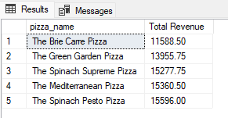

8. Top 5 Best seller pizzas by Quantity

SELECT TOP 5 pizza_name , CAST(SUM(quantity) AS decimal(10,2)) AS [Total Quantity]

FROM pizza_sales

GROUP BY pizza_name

ORDER BY 2 DESC;

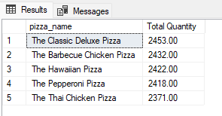

9. Bottom 5 Best seller pizzas by Quantity

SELECT TOP 5 pizza_name , CAST(SUM(quantity) AS decimal(10,2)) AS [Total Quantity]

FROM pizza_sales

GROUP BY pizza_name

ORDER BY 2 ASC;



10. Top 5 Best seller pizzas by Order

SELECT TOP 5 pizza_name , COUNT(DISTINCT order_id) AS [Total Order]

FROM pizza_sales

GROUP BY pizza_name

ORDER BY 2 DESC;

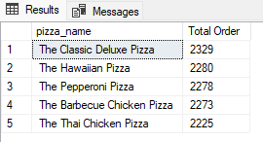

11. Bottom 5 Best seller pizzas by Order

SELECT TOP 5 pizza_name , COUNT(DISTINCT order_id) AS [Total Order]

FROM pizza_sales

GROUP BY pizza_name

ORDER BY 2 ASC;

